Contact

123-456-7890 hello@reallygreatsite.com 123 Anywhere St., Any City www.reallygreatsite.com

Experience

APPLICATIONS DEVELOPER Fauget Company
2020 - Present

WEB CONTENT MANAGER Borcelle Company
2018 - 2020

ANALYSIS CONTENT Larana Company
2015 - 2016

WEB DEVELOPER

Salford Company

2013 - 2014

Sebastian Bennett
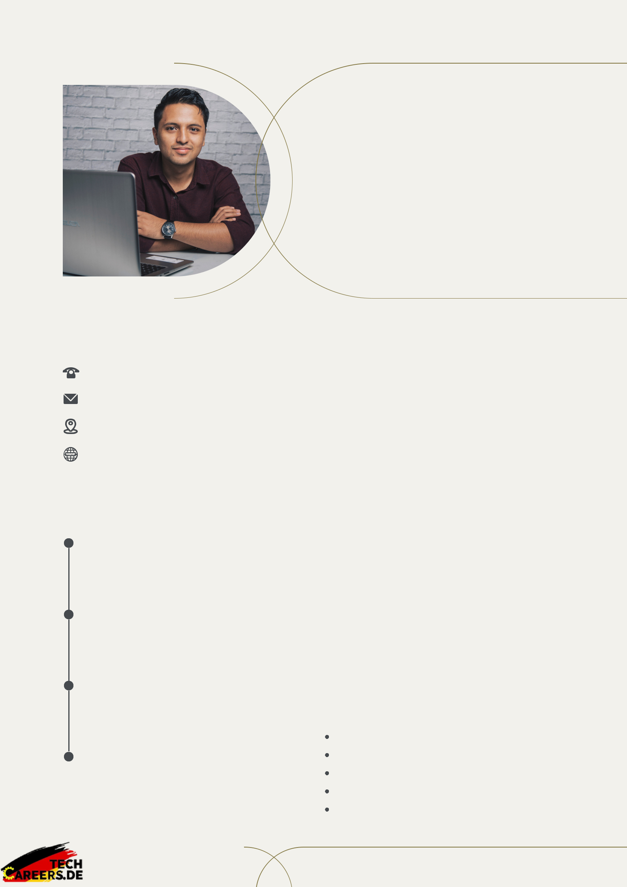

WEB DEVELOPER

Profile

I am a qualified and professional web developer with five years of experience in database administration and website design. Strong creative and analytical skills. Team player with an eye for detail.

Education

MASTER OF TECHNOLOGY Salford University

2018 - 2020

BACHELOR OF TECHNOLOGY Fauget University

2014 - 2016

Skills

Web Design

Design Thinking

Front End Coding

Problem-Solving

Strong Communication

