+123-456-7890

hello@reallygreatsite.com

www.reallygreatsite.com

123 Anywhere St., Any

City, ST 12345

Education

Bachelor of Design

Wardiere University

2006 - 2008

Bachelor of Design

Wardiere University

2006 - 2008

Expertise

Digital Marketing

Branding

Copywriting

SEO

Language

English

French

OLIVIA WILSON
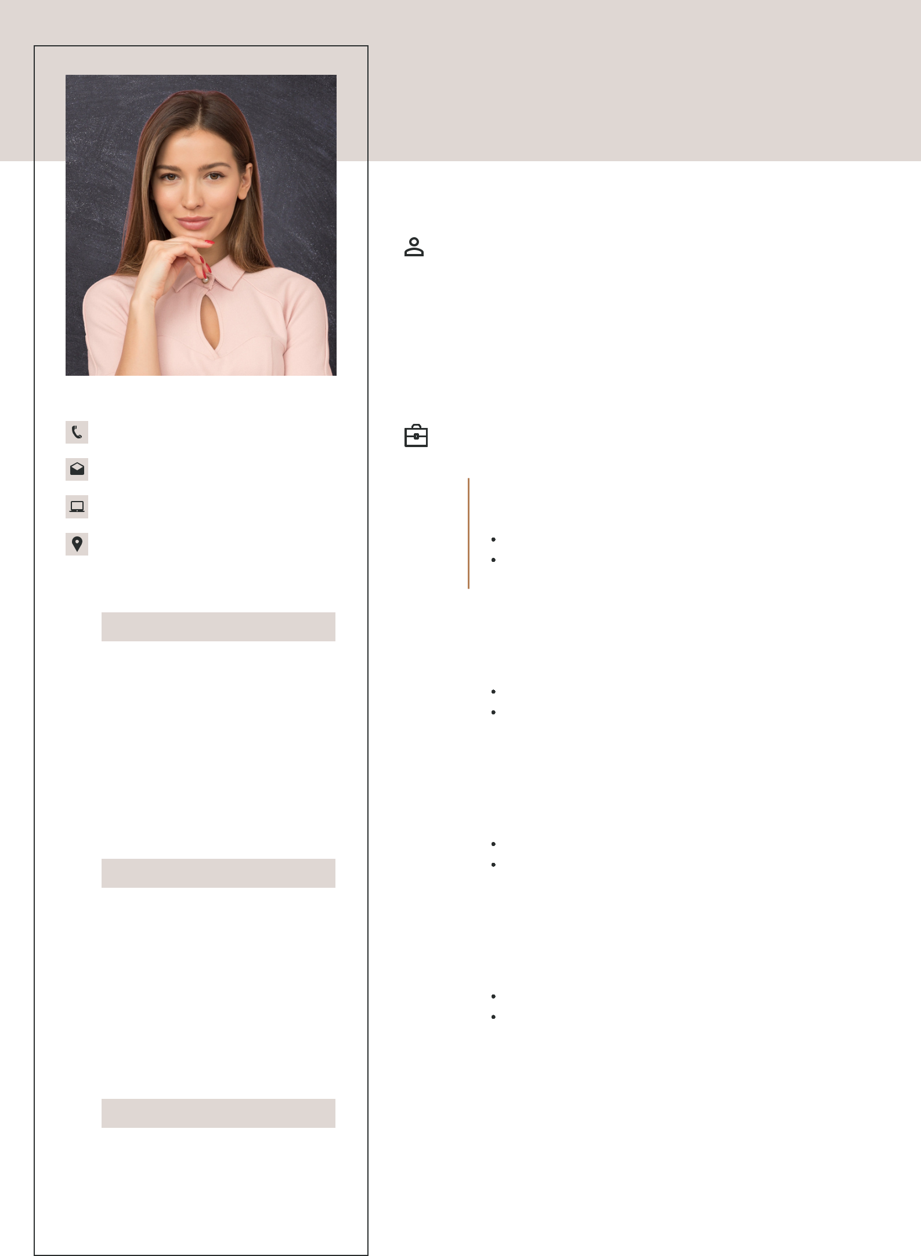

Graphics Designer

Profile

Lorem ipsum dolor sit amet, consectetur adipiscing elit, sed do eiusmod tempor incididunt ut labore et dolore magna aliqua. Ut enim ad minim veniam, quis nostrud exercitation ullamco laboris nisi ut aliquip ex ea commodo consequat.

 | Work Experience
2020 | Ginyard International Co.
– | Product Design Manager
2023 | Product Design Manager
Working with the wider development team.

Manage website design, content, and SEO Marketing,

Branding and Logo Design

2019 |  | Arowwai Industries
- |  | Product Design Manager
2020 |  | Product Design Manager
2020 |  | Working with the wider development team.
 |  | Manage website design, content, and SEO Marketing,
 |  | Branding and Logo Design

2017 |  | Ginyard International Co.
- |  | Product Design Manager
2019 |  | Product Design Manager
2019 |  | Working with the wider development team.
 |  | Manage website design, content, and SEO Marketing,
 |  | Branding and Logo Design

2017 |  | Arowwai Industries
- |  | Product Design Manager
2019 |  | Product Design Manager
2019 |  | Working with the wider development team.
 |  | Manage website design, content, and SEO Marketing,
 |  | Branding and Logo Design

