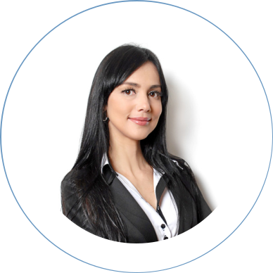

EDUCATION

Master Of Marketing

Fauget University

2008 - 2012

Master Of Marketing

Fauget University

2008 - 2012

Master Of Marketing

Fauget University

2008 - 2012

SKILLS

Digital Marketing

Branding

Copywriting

SEO

Marketing

Story writing

Branding

Digital Marketing Tool

LANGUAGES

ENGLISH

FRENCH

GERMANY

SAMIRA HADID

Digital Marketing Specialist

+123-456-7890 hello@reallygreatsite.com

www.reallygreatsite.com 123 Anywhere St., Any City

ABOUT ME

Lorem ipsum dolor sit amet, consectetur adipiscing elit, sed do eiusmod tempor incididunt ut labore et dolore magna aliqua. Ut enim ad minim veniam, quis nostrud exercitation ullamco laboris nisi ut aliquip ex ea commodo consequat.

WORK EXPERIENCE

Digital Marketing Manager | 2019 - 2022
Company Name l Location

Lorem ipsum dolor sit amet, consectetur adipiscing elit. Nullam pharetra in lorem at laoreet. Donec hendrerit libero eget est tempor, quis tempus arcu elementum. In elementum elit at dui tristique feugiat. Mauris convallis, mi at mattis malesuada, neque nulla volutpat dolor, hendrerit faucibus eros nibh ut nunc.

Social Media Manager | 2017 - 2019
Company Name l Location

Lorem ipsum dolor sit amet, consectetur adipiscing elit. Nullam pharetra in lorem at laoreet. Donec hendrerit libero eget est tempor, quis tempus arcu elementum. In elementum elit at dui tristique feugiat. Mauris convallis, mi at mattis malesuada, neque nulla volutpat dolor, hendrerit faucibus eros nibh ut nunc.

Social Media Manager | 2015 - 2017
Company Name l Location

Lorem ipsum dolor sit amet, consectetur adipiscing elit. Nullam pharetra in lorem at laoreet. Donec hendrerit libero eget est tempor, quis tempus arcu elementum. In elementum elit at dui tristique feugiat. Mauris convallis, mi at mattis malesuada, neque nulla volutpat dolor, hendrerit faucibus eros nibh ut nunc.

REFERENCES

Estelle Darcy Harper Russo

Wardiere Inc. / CEO Wardiere Inc. / CEO

Phone: +123-456-7890 Phone: +123-456-7890

